Dual Language Translator

Piyarathne SHMCS¹, Arudchelvam T²
Department of Computing & Information Systems, Faculty of Applied Sciences, Wayamba University of Sri Lanka
Chathuri537@gmail.com¹

ABSTRACT

This paper details the development of a dual-language translation mobile application designed to facilitate real-time translation between English, Sinhala, and Tamil. Built using Flutter for the frontend and Python Flask for the backend, the application supports mixed-language inputs a common communication style in multilingual regions. The app incorporates Neural Machine Translation (NMT) techniques, particularly Transformer models, to achieve high translation accuracy while respecting the grammatical and syntactic structures of the target languages, such as the subject-object-verb (SOV) order in Sinhala and Tamil. The application addresses significant challenges in machine translation, including handling code-switched inputs and maintaining contextual and idiomatic relevance. Features like language selection, history viewing, and starred translations enhance usability and user engagement. Testing results reveal an average BLEU score of 0.85, high user satisfaction ratings, and a translation response time averaging 1.5 seconds. While the app demonstrates robust functionality, limitations remain in translating idiomatic expressions and certain complex sentence structures. Future work will focus on expanding language support, adding offline capabilities, and integrating voice-to-text features to broaden accessibility. This project contributes to computational linguistics by providing an effective tool for real-time multilingual communication, addressing a critical need in underrepresented language research.
KEYWORDS: Bilingual Translation, Flutter, Natural Language Processing, Sinhala, Tamil

INTRODUCTION
Globalization has transformed how individuals communicate across languages, particularly in multilingual regions. Existing translation tools often fail to handle real-time, mixed-language inputs effectively, particularly for underrepresented languages like Sinhala and Tamil. These gaps create barriers to effective communication in multilingual societies.
The "Dual Language Translator" project addresses these challenges by providing an intuitive, cross-platform mobile application that translates between English, Sinhala, and Tamil. Utilizing Flutter for the frontend and Python for the backend, the app focuses on mixed-language inputs while maintaining fluency and contextual accuracy. This paper highlights the project's methodology, results, and future potential.

LITERATURE REVIEW
Machine Translation (MT) has evolved significantly, from rule-based systems to Neural Machine Translation (NMT). NMT leverages neural networks to process complex syntax and idiomatic expressions effectively. Models like Transformers, introduced by Vaswani et al. (2017), utilize self-attention mechanisms to improve translation quality, particularly for context-sensitive inputs.
Code-switching, or mixed-language input, is common in multilingual communities but presents challenges for traditional MT systems. Identifying language boundaries and preserving contextual accuracy are critical issues in this domain. Low-resource languages, such as Sinhala and Tamil, pose additional difficulties due to limited annotated datasets and their unique syntactic structures.
Mobile-based MT tools have gained popularity for their accessibility. Flutter enables cross-platform development with responsive user interfaces, while Python, paired with frameworks like Flask, supports scalable and efficient backend processing. Despite advancements, mobile translation apps capable of handling mixed-language inputs remain limited.

.methodology
The application employs a user-centered design and an iterative development approach. The technology stack includes:
3.1 Frontend
Flutter is used for the mobile app's interface, ensuringcross - platform compatibility.
Key features include:

- Dual-language input support with real- time text handling.

Figure 1:UI of dual translator app

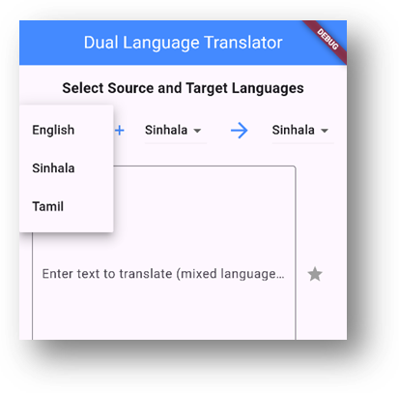
-
Dropdown menus for selecting input and target languages.

Figure 2: Drop down Menu
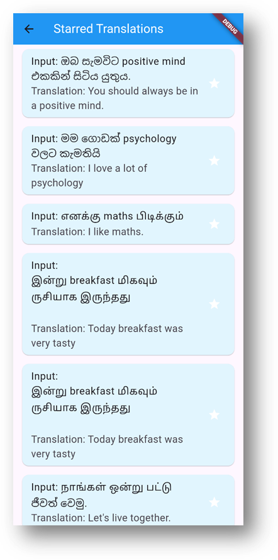
- History and starred translations for user convenience.

.

3.2 Backend
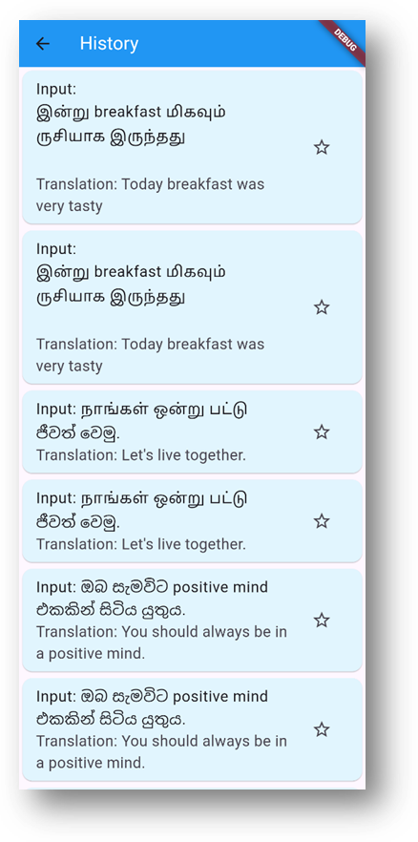
Flask serves as the backend framework, handling translation requests and managing the database. The translation process involves:
- Language detection for mixed-language inputs.
- Neural Machine Translation using the Hugging Face Transformers library.
- MySQL for storing translation history and starred translations.
Figure 3 : History Page

Figure 4 :Starred Page

3.3 Workflow
The frontend communicates with the backend via RESTful APIs. Translations are processed in real time, with results displayed to users almost instantaneously.

4. RESULTS AND DISCUSSION
4.1 Translation Accuracy

- BLEU Score: 0.85, indicating high similarity to human translations.
- User feedback: Over 90% satisfaction in fluency and grammatical accuracy.

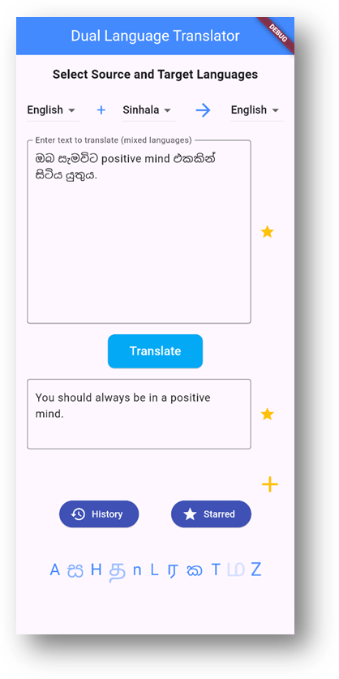
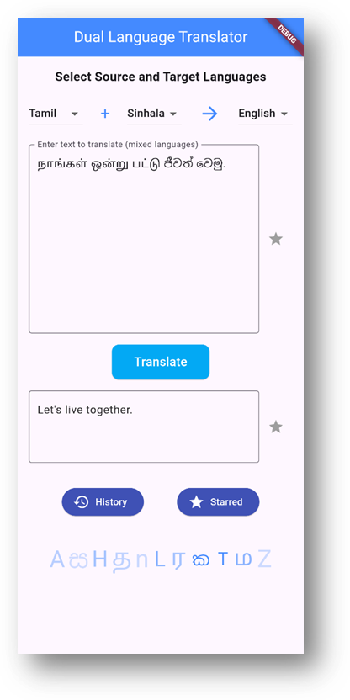
Figure 5: English & Sinhala mixed input

